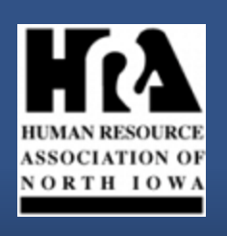
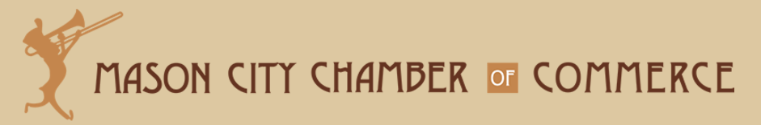

Professional Development Opportunity
Join us!  September 13, 2016  8a.m.-Noon | Leadership, Talent Management & Results  The future of our organization depends on our ability to hire, develop and retain our workforce to achieve results. This session will combine research findings and best practices in place for employers to evaluate current systems and identify improved practices to manage talent. Come learn more about how leadership, culture, talent management practices and everyday dialogue makes a bottom-line difference as well as a changed customer experience. Focus your efforts on leading every day actions that build accountability for employees. Discussion and activities will focus on actions participants can apply right back on the job.  At the end of this session, participants should be able to:  - Recognize the key components of effective talent management  - Identify resources and solutions for performance-based challenges  - Evaluate conflict resolution techniques to resolve problems and keep employees  - Apply research-based solutions to existing processes
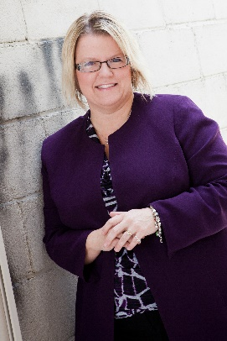
Our Speaker/Facilitator
Celina Peerman is returning to the area to lead this session for us and brings with her over 24 years of experience working in a variety of organizations and industries. Her specialty is workplace performance and organizational development initiatives. Celina has seen many of the best practices and challenges for employers in the region, the state, across the country and even internationally. Through a combination of research, a sense of humor and real tools, this session is designed for leaders and individual contributors who are actively working on increasing an organization’s work to recruit, relate and retain quality employees. Celina and her team are based in Waverly and in 2015, met with over 250 groups in Iowa and beyond for a total of about 6000 people. They are passionate about helping employees learn so organizations can improve. Learn more at: www.peermangroup.com.

